Airswift Holdings Ltd.

HSE Management System

GHS – Hazardous Communication Standards

Important Notice:
- This procedure is a Controlled Document and shall not be amended without the authority of the Operations Manager – North America.
- Any queries or feedback concerning the contents of this Procedure should be addressed to the Operations Manager – North America.
- This procedure is reviewed annually or when there is a change to business practices.
- This document should be retained indefinitely and only removed should the procedure become obsolete.
Prepared |  |  | Reviewed |  |  | Approved |  |  | EffectiveDate | Issue Number
 | Carol Stallworth |  |  | Courtney Rife |  |  | Sam Cross |  | 06/11/2021 | 5
 | Name |  |  | Name |  |  | Name
 | Carol Stallworth |  |  | Courtney Rife |  |  | Sam Cross
 | Signature |  |  | Signature |  |  | Signature
Version Number | Effective Date | Author | Amendments | Reason for Amendments
1 | 12/01/2017 | Julia Arevalo |  | Update
2 | 07/01/2019 | Carol Stallworh | Regulatory review | Update
3 | 06/04/2020 | Carol Stallworth | Regulatory review | Review
4 | 12/01/2021 | Carol Stallworth | Regulatory review | Review
5 | 06/11/2022 | Carol Stallworrth | Regulatory review | Review

INDEX
- PURPOSE
- SCOPE
- RESPONSIBILITY
- PROGRAM
- TRAINING
- STORAGE
- NON-ROUNTINE TASKS
- PROGRAM COMPLIANCE
- MULTI-EMPLOYER WORKPLACE
- ACKNIOWLEDGEMENT OF RECEIPT OF HAZARD COMMUNICATION TRAINING

- PURPOSE

The purpose of the Hazard Communication Program (HAZCOM) is to classify the hazardous chemicals and materials in the workplace and communicate theses hazards to employees. This program is now aligned with the Globally Harmonized System of Classification and Labeling Chemicals (GHS). Employees must know the hazardous properties of chemicals and materials to be safe during their use, handling or accidential contact. Safety Data Sheets (SDSs), labeling and training are all used to educate employees of the hazards associated with chemicals in the workplace

- SCOPE

This policy applies to all Airswift Employees and Contractors. The GHS- HAZCOM program does not apply to non hazardous chemicals or material subject to the Consumer Product Safety Act. This document was developed to provide information, safe work practices and the knowledge to identify chemicals in the workplace for all workers.

- RESPONSIBILITY

The Safety Department is responsible for ensuring that responsible person noted herein adhere to this program and report properly.

  - AIRSWIFT SAFETY DEPARTMENT

Safety Department shall:

- Provide oversight support of the HAZCOM Program.
- Conduct a periodic review of the program to ensure effectiveness and develop employee training.
- Identify Personal Protective Equipment (PPE) and train on use to prevent exposure.

  - HOST CLIENT HSE DEPARTMENT

- Is responsible for developing, maintaining and sharing with contractors a complete hazardous chemical inventory list and the corresponding Safety Data Sheets for their specific site. Host Client will ensure Contractors are trained on where to find their Safety Data Sheets.
- Host Client HSE Department will notify employees and contractors whenever a new hazardous chemical is introduced into the workplace or whenever employees will be using new chemicals.
- Advise employees of any associated hazards provide training on the content of the chemicals and personal protective equipment needed to prevent exposure.

  - AIRSWIFT EMPLOYEES (CONTRACTORS)

- Read and understand the SDSs for each hazardsous chemical or material to which they may be exposed.
- Participate in the HAZCOM Training Program
- Report any unlabed containers of hazardous chemical or materials to Superviosn.
- Is responsible for notifying the Host Client HSE Department when new chemicals are introduced to the work environment.
- Complete hazardous chemical inventory list and the corresponding Safety Data Sheets for specific chemicals they bring onto the client site.

- PROGRAM

The following items are to be followed to ensure compliance with the OSHA Hazard Communication Standard and the safety of our employees.

  - HAZARDOUS CHEMICAL LIST
A list of the hazardous materials and chemicals used in the course of the Airswift employee workplace activities will be maintained and updated by the Host Client’s Health Department. Any change in worksite hazards, Airswift contract employees will notify the Host Client’s HSE Department and their Airswift Service Consultant to ensure all employees are properly trained.
An annual review of the list shall be preformed to ensure the list is current. All hazardous materials that are no longer approved for use but be declared obsolete and removed from the list and inventory.
The chemical list must include:
- Product chemical name of all hazardous materials present in the workplace
- SDS revision date
- Manufacturer of the the chemical
- Quanity by volume and location of any bulk storage

  - SAFETY DATA SHEETS – SDS

Airswift Safety Department will communicate with the Host Client’s HSE Department to ensure the client site SDS are organized, up to date and available to all Airswift employees at free will.
Electronic access and other alternatives to maintain paper copies of the SDSs are permitted as long as they do not create barriers to employee access.

It is the responsibility of the Host Client’s HSE Department to update and maintain the SDSs for client worksites. Airswift Safety Department are responsible for communicating to all internal Airswift employee’s if there are any hazardous chemicals located in our internal offices. Training and communication will be provided on where to locate and read Safety Data Sheets for any hazardous chemicals used at any Airswift internal office location.

If a hazardous chemical or substance is received without a proper SDS, the receiving person will immediately notify the Host client HSE Department immediately to contact the manufacturer or distributor of the product. If the manufacturer or distributor is unable to produce an SDS, the Host Client HSE Manager will have the product returned to the supplier. Airswift Safety department are responsible for managing the SDS that come into any interal Airswift office locations.

    - SECTIONS ON A SAFETY DATA SHEET

The Globally Harmonized System (GHS) requires chemical manufacturers, distributors, or importers to provide Safety Data Sheets (SDSs) to communicate the hazards of chemical products. GHS requires SDSs to be in a uniform format that must include the section numbers, headings, and associated information listed below:

    - SAFETY DATA SHEET SECTIONS

Section 1, Identification  Includes product identifier; manufacturer or distributor name, address, phone number; emergency phone number; recommended use; and restrictions on use. | Section 2, Hazard(s) identification  Includes all hazards regarding the chemical and required label elements.
Section 3, Composition/information on ingredients  Includes information on chemical ingredients and trade secret claims. | Section 4, First-aid measures  Includes important symptoms/effects, including acute or delayed and required treatment.
Section 5, Fire-fighting measures  Lists suitable extinguishing techniques and equipment and chemical hazards from fire. | Section 6, Accidental release measures  Lists emergency procedures; protective equipment; proper methods of containment; and cleanup.
Section 7, Handling and storage  Lists precautions for safe handling and storage, including incompatibilities. | Section 8, Exposure controls/PPE  Lists OSHA’s Permissible Exposure Limits (PELs); Threshold Limit Values (TLVs); appropriate engineering controls; and personal protective equipment.
Section 9, Physical and chemical properties  Lists the chemical’s characteristics. | Section 10, Stability and reactivity  Lists chemical stability and possibility  of hazardous reactions.
Section 12, Ecological information*  Section 13, Disposal considerations*  Section 14, Transport information* | Section 15, Regulatory information*  Section 16, Other information  Includes the date of preparation or last revision.
Employers must ensure that SDSs are readily accessible to employees.
*Note: Since other agencies regulate this information, OSHA will not be enforcing Sections 12 through 15 of 29 CFR 1910.1200(g)(2).

    - SAMPLE SDS SHEET

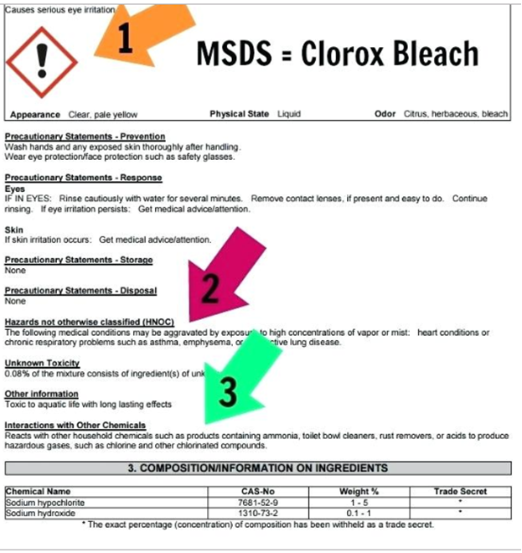

  - LABELING AND PICTOGRAMS

Each container of a hazardous chemical must be properly labeled with the identity of the hazardous material, the appropriate hazard warnings, pictogram(s), signal word(s), and the name and address of the manufacturer. Appropriate labels must be on all containers, regardless of size. Containers must be approved and recommended for storage and/or dispensing of the hazardous chemicals contained in them.

Worn and torn labels must be replaced. It is the responsibility of employees to report inappropriate labels to their supervisor. It is the responsibility of Host Client’s HSE Department to ensure that appropriate labels are in place and that replacement labels are available on their site. Airswift Safety Department will be responsible for maintaining labels of any chemicals used/stored on our internal office locations.

    - SECONDARY CONTAINER LABELING
Secondary containers are smaller than the original chemical container which usually include spray bottles, jugs or jars. These containers hold chemicals that are transferred from a primary container. Secondary container must include the same product SDS label as the original container. GHS labeling does not have to include the following:

      - Manufacturer’s name and address
      - Precautionary statements
      - Hazardous statements

    - SAMPLE LABELS

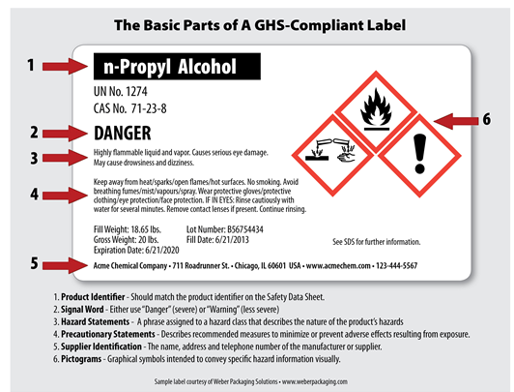

    - PICTOGRAMS AND HAZARDS

Pictograms for part of the international Globally Harmonized System of Classification and Labelling of Chemicals. There are two sets included in the GHS, labeling of containers and workplace hazard warning and transportation of dangerous goods.

      - CONTAINER LABELING OF WORKPLACE HAZARDS
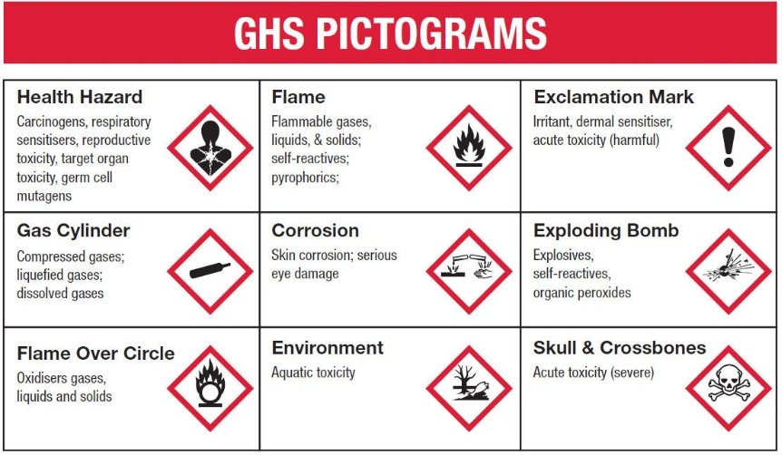

      - TRANSPORATION OF DANGEROUS GOODS
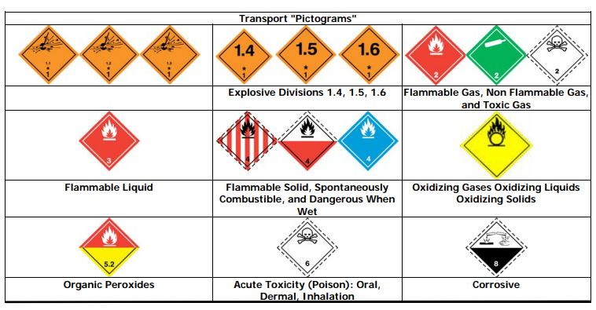

- TRAINING

Prior to starting work, each Airswift employee is required to attend GHS – Hazardous Communication Training. Training will include the following topics:

  - Identified hazardous chemicals in the workplace
  - How to recognize exposure to hazardous chemicals
  - Safety Sheet format and content
  - How to access SDSs
  - How to obtain a copy of the GHS Hazardous Communication program
  - Workplace labeling system and to ensure containers are labeled
  - Product identifier – how hazardous chemical is identified
  - Signal Work – used to indicate the relative level of severity
  - Precautionary statement – phrase to describe recommended measures that should be taken to minimize or prevent adverse effects resulting from exposure.
  - Pictogram – eight required specific shaped image to indicate visual hazard.
  - Hazard statement – describe the nature of the hazard of a chemical, including the degree of the hazard.
  - Personal protective equipment required
  - Proper work practices to assure proper use and handling of chemicals
  - Emergency Spill Response and Clean up
  - Proper reporting

(NOTE: If required, Department of Transportation (DOT) pictograms and identification placards should also be included in this training.)

Each affected employee working for or associated with Airswift is required to review the training material during the new hire onboarding training and sign the acknowledgment form, which will be placed in the employee’s file. This training is to be done during the new employee orientation process before the new employee assumes status as an active employee.

Employees will receive in depth Host Client job specific training on any hazardous chemical/material in the workplace by the Host Client HSE Department before the chemical/material is used or when changes are made to the program.

Retraining will be required when a chemical hazard changes or when a new hazard is introduced into the workplace.

- STORAGE

All storage areas for hazardous substances will be secured, properly ventilated, and identified by signs.

- NON-ROUTINE TASKS

Before any non-routine task is performed, employees shall be advised and/or they must contact Host Client HSE Department for special precautions to follow and shall inform any other personnel who could be exposed.

If a non-routine task is necessary, Airswift Safety Department shall be responsible for informing any internal Airswift employee any information about the activity as it relates to the specific chemicals expected to be encountered. The Host Client HSE Department will be responsible for informing any employee/contractor on their site with information about the activity as it relates to the specific chemicals expected to be encountered:
  - Specific wok instructions
  - Specific chemical name(s) and hazard(s);
  - Personal protective equipment required and safety measures to be taken;
  - Measures that have been taken to lessen the hazards including ventilation, respirators; and
  - Emergency procedures.

Host Client HSE Department will contact each contractor before work starts to gather and disseminate any information concerning chemical hazards the contractor is bringing into the workplace. The Host Client HSE Department will be responsible for documenting all processes as it relates to non-routine tasks and share a copy with Airswift Contractors and Service Consultants.

- PROGRAM COMPLIANCE

Any direct or intentional violation or non-compliance with this program may result in the termination of the person or persons involved in accordance with company policy.

- MULTI-EMPLOYER WORKPLACE

It is the responsibility of the Host Client HSE Department to provide contract employers of any other employees at the work site with the following information:

  - Copies of SDSs (or make them available at a central location) for any hazardous chemicals that the other employer(s)’ employee may be exposed to while working.
  - Inform other employers of any precautionary measures that need to be taken to protect employees during normal operating conditions or in foreseeable emergencies.
  - Provide other employers with an explanation of the labeling system that is used at the work site.

- ACKNOWLEDGEMENT OF RECEIPT OF HAZARD COMMUNICATION TRAINING

My signature below acknowledges I have received training concerning Hazard Communications. I understand that this training fulfills the employee training requirement of the Occupational Safety and Health Administration (OSHA) Hazard Communication Standard.

The jobsite and classroom training included the following:

  - Understanding the purpose and scope of the OSHA Hazard Communication Standard.

  - Explanation of the existence of federal, state and local right-to-know laws.

  - Definition of the classification “hazardous chemical.”

  - Explanation of situations and elements that must be present for a material to be considered a health hazard.

  - Explanation and interpretation of labels, what is required on all containers, and the Hazard Materials Identification System (HMIS).

  - Understanding and interpretation of Safety Data Sheets and pictogram(s).

  - My responsibilities as an employee of Airswift .

  - Policies and procedures to follow in case of exposure.

Employee Name: _______________________

Employee Signature: _____________________ Date of Training: ____________

